RESEARCH PAPER

|  |  |  |  |
| --- | --- | --- | --- |
| **Project Title-** Parking Space Counter | | | |
|  | | | |
| **Project Team-** | | | |
| **Team Designation** | **Name** | **UID** | **Section** |
| **Lead** | **Rishit Gupta** | **20bcs1270** | **602-A** |
| **Member1** | **Abhijeet Kaur** | **20bcs1326** | **602-B** |
| **Member2** | **Mehakpreet Kaur** | **20bcs1320** | **602-B** |

# Supervisor: Er . Neha Co-Supervisor:Anandita Jamwal

Signature:  Signature: 

**Abstract**

**The primary intention of this undertaking is to lessen the traffic within the parking area. commonly we are able to see in the multiplexes, cinema halls, big industries, and characteristic halls there is problem they have to cross and seek which line is empty and which line having area to park the car, for parking then they want employees for parking in accurate function it is the cash ate up method. so that you could avoid this trouble automobile Parking system challenge is applied.**

**The parking space counter undertaken as a mission is based on applicable technologies. This undertaking has been advanced to perform the methods without difficulty and speedy, which is not feasible with the manuals systems, which are triumph over by means of this software program. This project is developed the use of OpenCv with Python.**

**The mission analyzes the system necessities after which comes up with the requirements specs. It studies other related structures after which give you gadget specs. The machine is then designed according with specifications to satisfy the necessities.**

**Parking area Counter find what number of total automobiles are gift and what number of areas are vacant to park. in this project, we are able to be the use of primary photograph Processing strategies to remedy this hassle.**

***Keywords— Parking system, vacant slots, traffic.***

INTRODUCTION

The analogy is that when a driver enters a parking zone, the primary thing the motive force does is to appear ahead for an indication that claims the car parking zone is crowded, crowded - or unoccupied. the motive force also doesn't know the way many there are and where they'll find a car parking zone - the section of his car.

a number of the parking lots may - 'remain unoccupied even when the full place is up. this can end in inefficient use of parking sections and traffic jam at the doorway to the parking zone.

Therefore, providing drivers with the proper information within the car parking zone during the entry into the parking zone becomes a vital problem. The proposed system called Counting Available car parking zone uses Image Processing. This program proposes the way to detect the presence of parked cars by analyzing the image of the lot captured by the surveillance camera and calculating the available parking zone displayed ahead of the doorway to the parking zone. The system uses images, as everywhere within the car parking zone are often seen with some cameras as compared.aside from that, the system is integrated and therefore the costs aren't expensive. a photograph of the car parking zone was taken by a surveillance camera mounted on a part within the car parking zone.

To alleviate the issues mentioned above, a creative parking system has been developed. With the assistance of an intelligent parking system, sponsors can easily find and secure an unoccupied automobile parking space in any lot that seems convenient for them.

The current transport infrastructure and car parks are considered insufficient to take care of traffic flow. Therefore, problems like hold up and inadequate parking are growing.

With the data provided, drivers are able to avoid crowded parking lots and find vacant parking lots elsewhere. the amount of illegally parked cars on the side of the road resulting in hold up has also decreased because it has entered parking lots .More importantly it can reduce hold up. All of this may make it easier for consumers.

EASE OF USE

1. very easy for authorities and vehicle owners to use it.
2. flexible and does not cause any inconvenience to its users. iii)easy to manage as well as control and regulate.
3. Our goal is to provide proper and accurate data regarding vacant slots.
4. The system is so optimized so that user don’t get any disturbance between work.

METHODOLOGY

Parking Space Counter in this we will find how many total cars are present and how many spaces are vacant to park. The best thing about the project is that we will be using basic Image Processing techniques to solve this problem.

There are Some Libraries used here in this Project:

## OpenCV :

OpenCV is an open-source library for the computer vision. It provides the facility to the machine to recognize the faces or objects. In this tutorial we will learn the concept of OpenCV using the Python programming language.

## Numpy:

NumPy is a Python library used for working with arrays. It also has functions for working in domain of linear algebra, fourier transform, and matrices.

NumPy was created in 2005 by Travis Oliphant. It is an open source project and you can use it freely.

NumPy stands for Numerical Python.

## Pickle:

Python pickle module is used for serializing and de-serializing python object structures. The process to converts any kind of python objects (list, dict, etc.) into byte streams (0s and 1s) is called pickling or serialization or flattening or marshalling. We can converts the byte stream (generated through pickling) back into python objects by a process called as unpickling.

## CVZone:

Cvzone is the library that develops a bridge between Arduino and python. With the help of the SerialObject module in Cvzone we can connect the arduino port with python as well as send data to arduino and can link any python code with it.

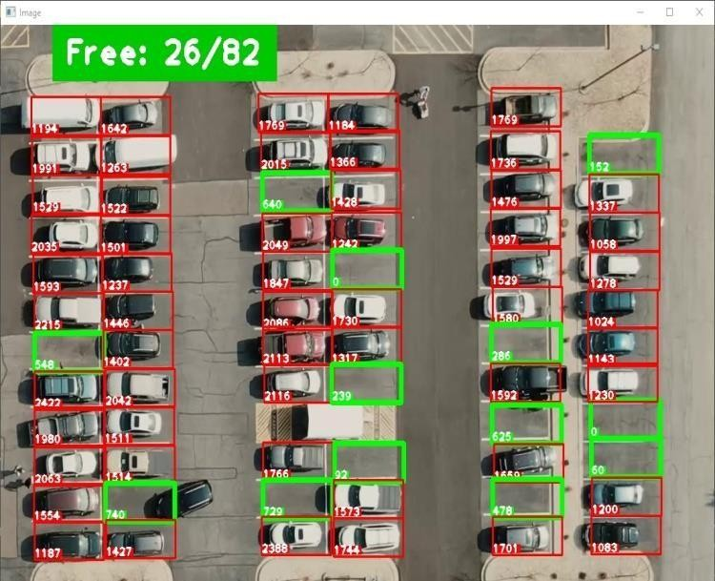

LITERATURE SURVEY

## Tobing, Aldo. (2021). EVALUATION OF PARKING SPACES AT THE CLEANERS. CERUCUK.

Sudimampir market is a complete shopping center in the city of Banjarmasin. Along with its running time, the market sudimampir into a crowded shopping mall visited by people of Banjarmasin and its surroundings for a complete and cost. Most visitors come the shop sudimampir market with a wholesale count.This research[1] was conducted for analyzing the characteristics of the vehicle parked at the location of the study include: accumulation of parking, the average duration of parking, parking volume, the total number of its full vehicle parking ,and right parking corner. Data collection was performed manually during holidays. Based on the survey results, in getting Parking Penatu is often not operating optimally by not using the appropriate SRP SNI and still perform manual calculations in the counter. The use of SRP SNI and a 30° angle allows for optimum laundry parking performance. So it can produce 67 pcs. PSP can

take 313 units. Wheeled vehicle 4. At the same time,

the parking lot can be fully functional depending on the function. That is, a parking lot in the city center.

**Demand forecast for parking spaces and parking areas in Olomouc**

The study[3] focuses on the issue of parking in Olomouc and in two localities of this city: the Foerstrova and Hodolany areas. In the first part of the manuscript, general data, approaches, and methods regarding the process of designing parking areas as well as the demand forecasting for parking spaces, when explaining the principles of regression analysis itself, are presented. The second part of the article, which represents a crucial section of the conducted research study, discusses the very analysis of the parking situation and parking demand forecasting for both areas being investigated. As for major findings, an increasing trend related to the number of cars per 1,000 inhabitants in Olomouc can be observed. Furthermore, following the performed analyses and forecasts, it can be stated that there is a parking deficiency issue, which needs to be addressed in the future.

## Parking Space Recognition Method Based on Parking Space Feature Construction in the Scene of Autonomous Valet Parking by Shidian, ma & Fang, Weifeng & Jiang, Haobin & Han, Mu & Li, Chenxu. (2021).

At present, the realization of autonomous valet parking (AVP) technology does not achieve information interaction between the parking spaces and vehicles, and accurate parking spaces information perception cannot be obtained when the accuracy of the search is not precise.[4] In addition, when using the camera vision to identify the parking spaces, traditional parking space features such as parking lines and parking angles recognition are susceptible to light and environment. Especially when the vehicle nearby partially occupies the parking space to be parked, it is not easy to determine whether it is a valid empty parking space. This paper proposes a parking space recognition method based on parking space features in the scene of AVP. By constructing the multidimensional features containing the parking space information, the cameras are used to extract features’ contour, locate features’ position and recognize features. In this paper, a new similarity calculation formula is proposed to recognize the stained features through template matching algorithm. According to the relationship between the relative position of the

object and the parking space, the effective empty parking space and its boundary are identified. Experimental results show that compared with conventional parking line and parking angle recognition, this method simplifies recognition by identifying effective empty parking spaces even in difficult lighting conditions, and identifying parking

spaces partially occupied by surrounding vehicles. algorithm and improves the reliability of the parking spaces identification.

## Brozova, Helena & Ruzicka, Miroslav. (2020). THE PREDICTION OF PARKING SPACE AVAILABILITY.

Intelligent Parking System (IPS)[5] allows customers to select a parking lot based on their preference, park their

vehicle quickly without looking for a free parking

space (space), or reserve a space in advance while avoiding queues. There is. With IPS, you can reduce fuel (energy) losses when looking for a parking space and, consequently, reduce harmful emissions. Some systems interact with invehicle navigation systems and provide users with information in realtime such as free places available at a given parking lot (car park), the location and parking fees. Few of these systems, however, provide information on the forecasted utilisation at specific time. This paper describes results of a traffic survey carried out at the parking lot of supermarket and the proposal of the model predicting realtime parking space availability based on these surveyed data. The proposed model is formulated as the nonhomogenous Markov chains that are used as a tool for the forecasting of parking space availability. The transition matrices are calculated for different time periods, which allow for and include different drivers’ behaviour and expectations. The proposed prediction model is suitable for the potential

use of IPS that supports various communication media such as the Internet, navigation (GPS, Galileo, etc.), and personal communication service (mobile phone).

## Sig langegger Park Space (2017)

In Chapter 8, I compare and contrast the design and regulation of four North Denver Parks: Saint Patrick’s Park (a community designed and constructed park), La Raza Park (once the cultural center of North Denver, now a monumental space), a section of Berkeley Park (a soccer field reconfigured as an offleash dog park), and Sloan’s Lake Park’s internal road system (changed to a pedestrian/bike path)[2]. I suggest that, working at a variety of geographical scales and along parallel temporal arcs, official and unofficial changes to the design and regulation of these parks fossilized ethnic biases into general acceptance, into new modes and means of belonging, and thereby contributed in incremental and cumulative ways to the gentrification of Highland..

Langegger, Sig. (2017). Park Space. 10.1007/9783319411774_8. In Chapter 8, I compare and contrast the design and regulation of four North Denver Parks: Saint Patrick’s Park (a community designed and constructed park), La Raza Park (once the cultural center of North Denver, now a monumental space), a section of Berkeley Park (a soccer field reconfigured as an offleash dog park), and Sloan’s Lake Park’s internal road system (changed to a pedestrian/bike path). I suggest that, working at a variety of geographical scales and along parallel temporal arcs, official and unofficial changes to the design and regulation of these parks fossilized ethnic biases into general acceptance, into new modes and means of belonging, and thereby contributed in incremental and cumulative ways to the gentrification of Highland.

RESULT

Parking is one of the major problems that is created by the increasing road traffic. It is an impact of transport

development. The availability of less space in urban areas has The availability of less space in urban areas has increased demand for parking space especially in areas like Central.

District.This affects the mode choice also.

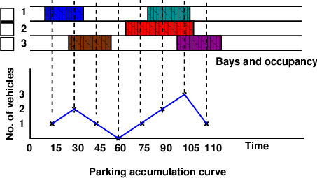

CONCLUSION AND FUTURE ACTIVITY

The main purpose of this paper is to study and analyze the

parking monitoring and control system to count the number of cars entering and leaving a parking and provide information about free parking spaces. We will use image processing techniques to find the total number of cars can be parked in the area and how many vacant slots left to be parked.

the occupancy count in the selected parking lot is taken at the beginning. Then the number of vehicles that enter the parking lot for a particular time interval is counted. The number of vehicles that leave the parking lot is also taken. The final occupancy in the parking lot is also taken. Here the labor required is very less. Only one person may be enough. But we won’t get any data regarding the time duration for which a particular vehicle used that parking lot. Parking duration and turn over is not obtained. Hence we cannot estimate the parking fare from this survey. For quick survey purposes, a fixed period sampling can also be done. This is almost similar to in-out survey. All vehicles are counted at the beginning of the survey. Then after a fixed time interval that may vary between 15 minutes to i hour, the count is again taken. Here there are chances of missing the number of vehicles that were parked for a short duration.

# REFERENCES

1.Tobing, Aldo. (2021). EVALUATION OF PARKING SPACES AT THE CLEANERS. CERUCUK. 5. 135. 10.20527/crc.v5i2.4318.

2. Langegger, Sig. (2017). Park Space. 10.1007/978-3-319-41177-4_8.

1. Cempírek, Václav & Turek, Michal & Kalupová, Blanka & Šaradín, Pavel. (2022). Demand forecast for parking spaces and parking areas in Olomouc. Open Engineering. 12. 11-16. 10.1515/eng-2022-0002.
2. Shidian, ma & Fang, Weifeng & Jiang, Haobin & Han, Mu & Li, Chenxu. (2021). Parking Space Recognition Method Based on Parking Space Feature Construction in the Scene of Autonomous Valet Parking. Applied Sciences. 11. 2759. 10.3390/app11062759.
3. Brozova, Helena & Ruzicka, Miroslav. (2020). THE PREDICTION OF PARKING SPACE AVAILABILITY. Transport